XCRAM
Use Case Specification

Submitted to:

Asst. Prof. Ma. Rowena C. Solamo
Faculty Member
Department of Computer Science
College of Engineering
University of the Philippines, Diliman

Submitted by:
Agluba, Gerry P.
Go, Sharleen Joy Y.
Silverio, Robelle C.

In partial fulfillment of academic requirements for the course

CS 191 Software Engineering I of the

1st Semester, AY 2016-2017

System: Task Scheduling System Page: 1
Version: 2.0 Group: TaskOverflow
Unique Reference:

The documents are stored in the https://github.com/sharleengo/XCRAM/tree/master/02-Requirements-Engineering

Document Purpose:

The purpose of this document is to present the use case specification of ‘View Task Information’ use case.

Target Audience:

Evaluators and users.

Revision Control

History Revision:
Revision | Person | Version | Modification
Date | Responsible | Number
09/28/16 | Robelle Silverio | 1.0 | Specified purpose, target audience, use case
 |  |  | name, use case description, use case
 |  |  | precondition, flow of events (scenarios along
 |  |  | with its description). Added activity diagram.
9/28/16 | Sharleen Joy Go | 1.1 | Added use case description.
9/22/16 | Robelle Silverio | 2.0 | Edited unique reference and use case name

System: Task Scheduling System Page: 2
Version: 2.0 Group: TaskOverflow

Use-Case Name:

Description:

Preconditions:

Flow of Events:

Use-Case 2.1 View Task Info

The User may view a specific task's information through this use case. The task title, type, start time, end time, duration, priority and constraints will be displayed.

At least one task is existing.
Scenario Name |  | Description
Scenario 1 (Basic Flow) | 1. The User wished to see the detailed information of a specific task.
User chose to view task’s | 2. A list of tasks for that day is shown. Each task is represented by a task
information and hides task’s | title.
information after viewing it | 3. A list of tasks for that day is shown. Each task is represented by a task
 | title.
 | 4. | Only one task can be viewed at a time so user can only choose one task
 | to view.
 | 5. | Task’s information will be viewed such as: task title, type, start time, end
 | time, duration, and constraints (if indicated by the user): priority and
 | preferred time range.
 | 6. | Task title is the name of the task added by the user.
 | 7. | There are two types of task such as flexible and fix.
 | 8. | Start time is when the specific task starts/started.
 | 9. | End time is when the specific task ends/ended.
 | 10. Duration is the number of hours/minutes a specific task needed to be
 | completely accomplished.
 | 11. Constraint/s is/are only applicable for flexible task.
 | 12. Priority (if given by the User; highest priority is 1).
 | 13. Preferred time range is morning/afternoon/evening.
 | 13. When User decided to hide task’s info, then it is no longer displayed.

System: Task Scheduling System Page: 3
Version: 2.0 Group: TaskOverflow

Scenario 2

User chose to view task’s information and didn’t hide task’s information after viewing it

- The User wished to see the detailed information of a specific task.

- A list of tasks for that day is shown. Each task is represented by a task title.

- A list of tasks for that day is shown. Each task is represented by a task title.

- Only one task can be viewed at a time so user can only choose one task to view.

- Task’s information will be viewed such as: task title, type, start time, end time, duration, and constraints (if indicated by the user): priority and preferred time range.

- Task title is the name of the task added by the user.

- There are two types of task such as flexible and fix.

- Start time is when the specific task starts/started.

- End time is when the specific task ends/ended.

- Duration is the number of hours/minutes a specific task needed to be completely accomplished.

- Constraint/s is/are only applicable for flexible task.

- Priority (if given by the User; highest priority is 1).

- Preferred time range is morning/afternoon/evening.

13. When User decided not to hide task’s info, then it is still displayed.

System: Task Scheduling System Page: 4
Version: 2.0 Group: TaskOverflow
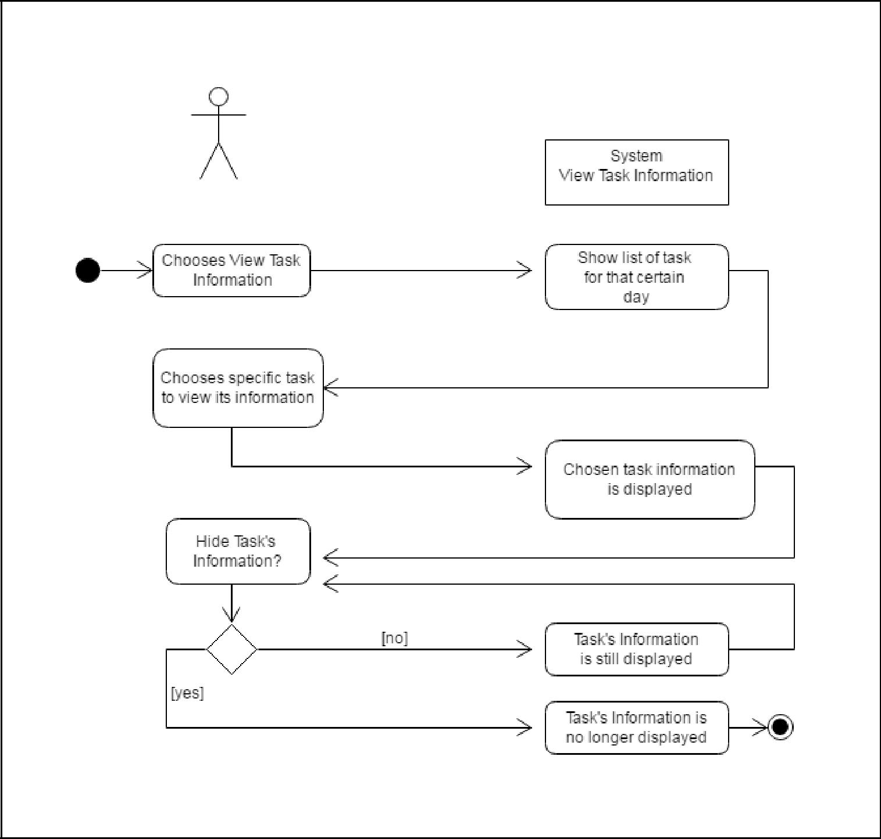

user

Activity Diagram of the flow of events:

System: Task Scheduling System Page: 5
Version: 2.0 Group: TaskOverflow
Post Condition: None

Relationship: None

Special Requirements: None

System: Task Scheduling System Page: 6
Version: 2.0 Group:TaskOverflow

